Lost and Found Management System
Group Members:
SYED ABEER RAZA TIRMIZI (Student ID: 25K-6526)
RAIYYAN HUSSAIN (Student ID: 25K-6520)

Submission Date: 28/APRIL/2026

1. Executive Summary:
- Overview: The Lost and Found Management System is a software application developed using C programming language with a graphical user interface. The main purpose of this project is to help manage lost and found items efficiently within an organization such as a university. The system allows users to add, search, update, and delete item records while also providing analytics about lost and found items.
- Key Findings: The system successfully organizes item records and improves accessibility. It reduces manual effort and ensures better tracking of lost and found items. The GUI makes it user-friendly, and features like search and analytics enhance usability.

2. Introduction:
- Background: In many institutions, lost and found items are managed manually, which often leads to misplacement and inefficiency. This project addresses that issue by providing a digital solution using programming fundamentals concepts such as structures, arrays, and functions.
- Project Objectives:
- To design a system that records lost and found items
- To provide search functionality for quick retrieval
- To implement update and delete features
- To create a user-friendly GUI using Raylib
- To analyze item trends (lost vs found)

3. Project Description:
Scope:
The system includes:
- Adding new items
- Viewing all items
- Searching items by ID or name
- Updating item details
- Deleting records
- Basic analytics
Excluded features:
- Online database integration
- Multi-user login system
- Cloud storage
Technical Overview:
- Programming Language: C
- GUI Library: Raylib
- Compiler: MinGW (GCC)
- IDE/Editor: Visual Studio Code

4. Methodology:
Approach:
The project was developed step-by-step:
- Planning system structure
- Dividing tasks among group members
- Implementing core features first
- Adding GUI later
- Testing and debugging
Roles and Responsibilities:
- Member 1: Core logic and data handling
- Member 2: Testing and GUI design using Raylib

5. Project Implementation:
1. Design and Structure:
The system is menu-driven with multiple screens:
- Main Menu
- Add Item Screen
- View Items Screen
- Search Screen
- Analytics Screen
The data is stored using structures and arrays.
2. Functionalities Developed:
- Add Item (with details like name, date, status)
- View all items
- Search item
- Analytics (lost vs found count)
3. Challenges Faced:
- Difficulty in setting up Raylib environment
- Handling user input in GUI
- Managing screen transitions
- Debugging compilation errors
Solution: These were resolved through testing, debugging, and proper configuration of compiler paths.

6. Results:
Project Outcomes:
The system works successfully and meets all objectives:
- Efficient item tracking
- Easy data management
- User-friendly interface
Screenshots and Illustrations:
- Main Menu
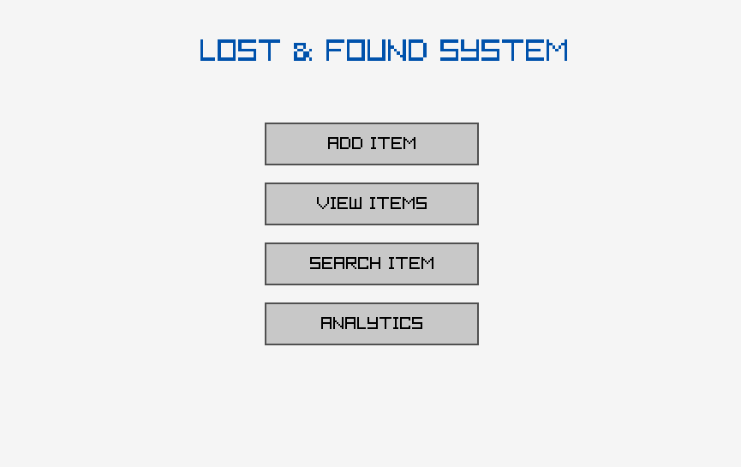
- Add Item Screen
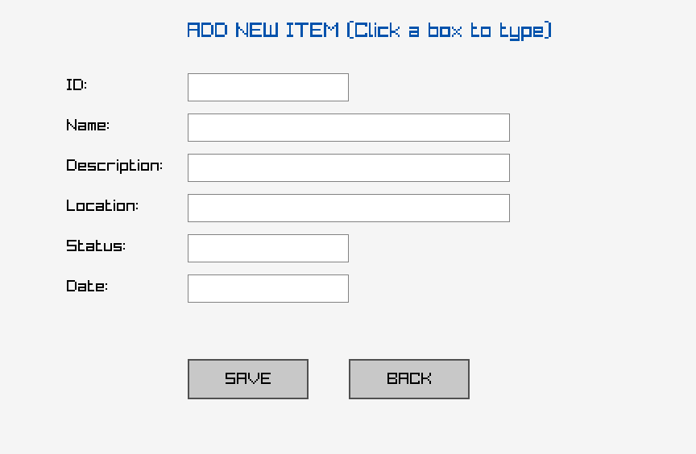
- View Items
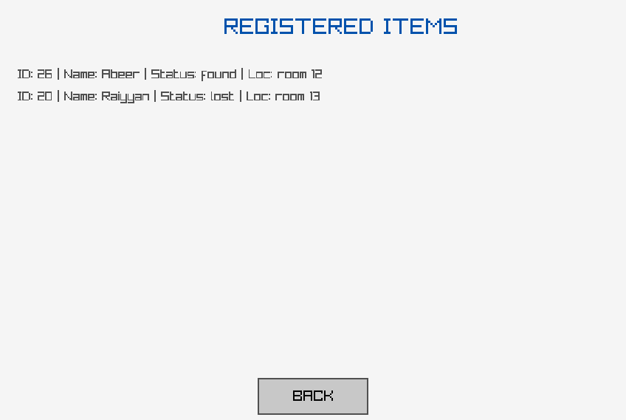
- Search Result
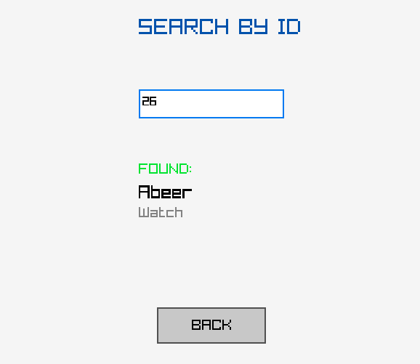
- Analytics Screen
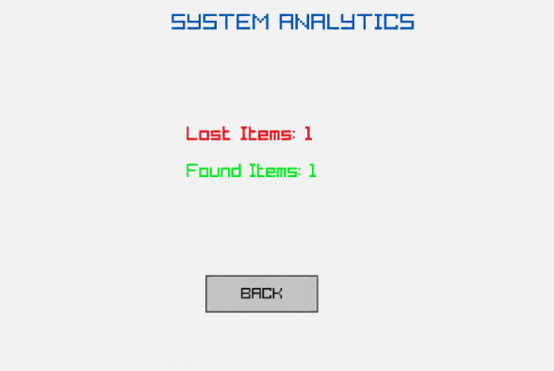

Testing and Validation:
The system was tested by:
- Adding multiple items
- Searching existing and non-existing items
- Updating and deleting records
- Checking GUI responsiveness
All functionalities performed correctly.

7. Conclusion:
- Summary of Findings: The Lost and Found Management System provides an effective solution for managing items digitally. It demonstrates the practical use of programming fundamentals and GUI development.
- Final Remarks: This project helped in understanding real-world problem solving using C programming. Future improvements can include database integration and mobile app development.

